Design a system for home security systems

value 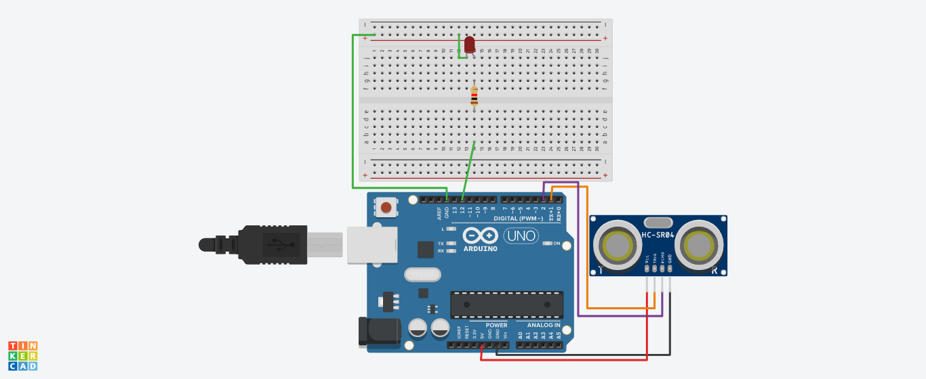

Theory:

In this experiment we use ultrasonic sensor as our main component. In Ultrasonic sensor transmitter sends ultrasonic Sound waves which get reflect by some object and received by receiver . By using this concept we perform our experiment.

Learning & Observation:

By doing this experiment we learn

1. How to code arduino for using ultrasonic sensor.
2. Basics of ultrasonic sensor.

Problems:

No value come on the serial monitor.

Troubleshoot:

Check all the connections of ultrasonic sensor properly .

Connect:

1. Vcc-5v.
2. Gnd-ground.

Precautions:

1. Connect all the pins properly.
2. In void setup the trig pin is output and echo pin is input.

Learning Outcomes:

After performing this experiment you learn how to make proper use of ultrasonic sensor and learn how to make a home security system.